Ethical Hacking
J0HK 34 – ASSESSMENT 02
Connor Campbell

Student Name: Connor Campbell
Student Number: 20197790
Date: 04/03/26
Contents
Introduction 2
Enumeration 3
Vulnerability Analysis 3
Manual Vulnerability testing 3
Maintaining Access 4
Covering Tracks 5
Countermeasures 5
Conclusion 5
Index 6

Introduction
A penetration test has been conducted with the purpose of identifying issues and implementing countermeasures to prevent exploitation of the target systems. The target operating system was a Windows XP and the attacker that was used for the penetration test was a Linux operating system running KALI. This penetration test was conducted professionally and ethically inside a controlled environment which was previously authorized by the client. The goal of this test is to identify issues within the security of the defender and ways to exploit the issues, create ways to maintain access and then cover all tracks and finally report all the steps taken to help with implementation of defenses.
Scope and rules of engagement
The scope of this Pen Test was determined by the client before the test took place which the target was decided being a windows XP operating system with the IP address of 192.168.80.128. I also used the tools Social engineering toolkit, Zenmap, Nessus and Metasploit as well as using an Apache2 server. The timeframe of the test took place over a week and permission decided was complete access to the defender system but prohibited Denial of service. No systems other than the defender was tested or targeted.
Reconnaissance
During Reconnaissance, Information is gathered to gain means of exploitation to the target system is collected without the system being aware of collection. To do this I used the networking tool zenmap to scan for any open ports and / or active hosts. Once the scan was performed the active hosts on the IP was show (Index.1), This provided us 6 IP addresses are active which shows that they are in use but doesn’t show which specific one is our target. I use Zenmap again using the Nmap command to identify all open ports and Operating Systems which reveals how the target is found with the IP address present (Index.2)

Enumeration
Enumeration interacts directly with the target system to gain more detailed information, I created a TCP connect scan within Zenmap to specifically target the IP address and identify its open ports as well as the running services connected to the address (Index.3). Attackers can use this information to gain knowledge of the system that’s targeted to create better exploits and plans.
Vulnerability Analysis
Vulnerability analysis is used to identify security weaknesses inside the target system as well as to determine severity and assess the impact of the system being exploited. Using the information that was gathered during the previous two steps we can move forward to see if any vulnerabilities are present. This is done both manually and Automatically
Automated vulnerability Testing
Automated Vulnerability testing was done by using a Nessus vulnerability scan to identify any vulnerability on the target IP. Automated scanners are used to quickly identify vulnerabilities by looking through vulnerability databases and very importing for identifying known security issues across multiple hosts. Our scan shows 98 vulnerabilities are identified across three IP addresses (index.4)

Manual Vulnerability testing
For Automated Vulnerability testing, a Nmap scan was used in terminal to discover any active hosts, this is done by using a command line command (index.5). Manual testing allows for more specific parameters and allows deeper knowledge on how systems interact to specific conditions.
Exploitation
The Exploitation stage is now conducted to see if the Vulnerability (SMB) can be used to gain access (Unauthorized) to the target system. To perform this exploit, I used the Social Engineering toolbox (SET) tool found pre-installed on Kali Linux to target the Windows Machine (IP:192.168.80.128) (Index.6,7,8,9). SET is being used to generate and deliver a payload to the Windows XP system by automating a Metasploit component including a reverse TCP handler that allows us to receive incoming communications from the target. The payload used was a windows meterpreter Reverse TCP payload setup to connect back to the attacking system (192.168.30.127) on port 4444.
Once the payload was executed SET shows a successful established meterpreter session (index.9), the target system sends back conformation that the connecting is communicating with the attacking system and that remote code execution could be used. Next, we used the Shell command (Shell) to allow commands to be run.
After the successful access, a variety of commands where ran to look through files like DIR to prove access to folders like “people” to show that the file structure of the system is accessible, the screenshots show that that creation of new files could also be done by using the echo command which shows the ability to modify data remotely allowing further harm to occur.
This proves that vulnerability was exploitable and would allow the attacker could maliciously damage systems and data of the system highlighting that unpatched legacy systems are a critical risk to data breaches, loss of data and other operational disruption.

Maintaining Access
After the exploitation the next step is to create ways to maintain access to the system to allow access to regained even if the current connection is terminated. A method used was the creation of a user account (Command:“net user hiddenuser 1234 /add”) and then giving it admin privileges (Command:” net localgroup Administrators hiddenuser /add”) by adding to the admin group. By giving the “hidden” account admin privileges means that if we need to access the system again we can directly login into the new “hidden” user account and not need to worry about re-entering the previous users account. Next I hid the “hidden” account by modifying the system registry (reg add "HKLM\SOFTWARE\Microsoft\Windows NT\CurrentVersion\Winlogon\SpecialAccounts\UserList" /v %USERNAME% /t REG_DWORD /d 0 /f”) to hide the user from the login screen of the windows machine to avoid detection as well as a backdoor was created on the original connection to the target which creates an automated task that starts the backdoor whenever a user logs in.

Covering Tracks
To cover our tracks, I deleted evidence of entry including deleting temporary files, changing event logs to hide any actions taken place as well as making sure all folders relating to the hidden user are hidden by setting them hidden in folder properties. This is all done to avoid the threat of detection and would require a diligent security analysis to identify rather than a started user to spot. This creates long-term risks to the client as the persistence of threat boosts the chances of repeat data breaches which can lead to effects of reputational loss and financial loss including fines.

Countermeasures
Some easy countermeasures that can be put in place are making sure firewalls are turned on, this on its own blocked the Reverse TCP handler from connecting to the client from creating a remote connection. Segmenting privileges also can prevent malicious damage as having users having specific privileges can avoid easy access to all areas of information and spread of other exploits to gain more access to connected systems. This shows that basic security measures to prevent large damaging issues from appearing and should be a priority.

Conclusion
In conclusion the most significant security weakness identified within the Windows XP system is that it’s at its End-of-life status with Microsoft stopping support and security updates around April 2014. This allows unpatched vulnerabilities to continue to exist in the operation system as well as weak configurations by default. The security of the system is low and should not be considered for the use of sensitive data handling and newer systems with regular patching should be used instead.

Index
(1), Zenmap host scan, Reconnaissance
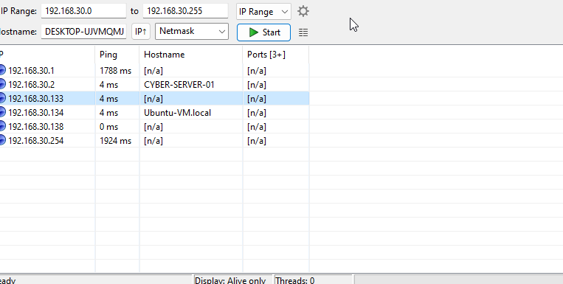
(2), Zenmap open ports scan, Reconnaissance
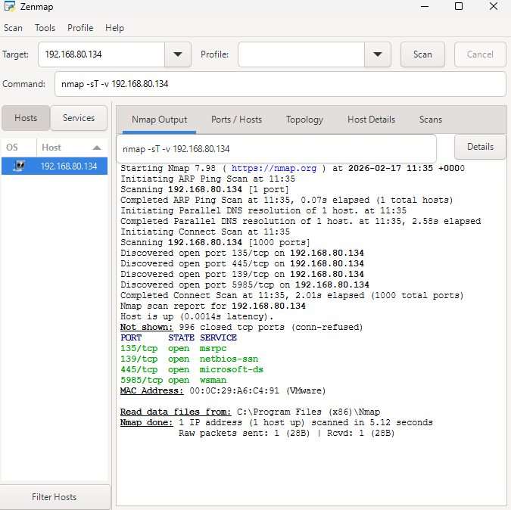
(3), Zenmap TCP connect scan, Enumeration.
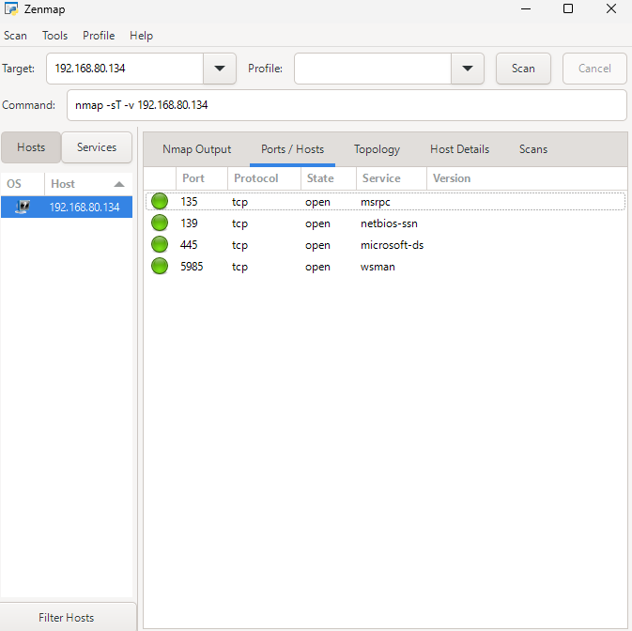
(4), Nessus vulnerability scan, Automated Vulnerability Analysis
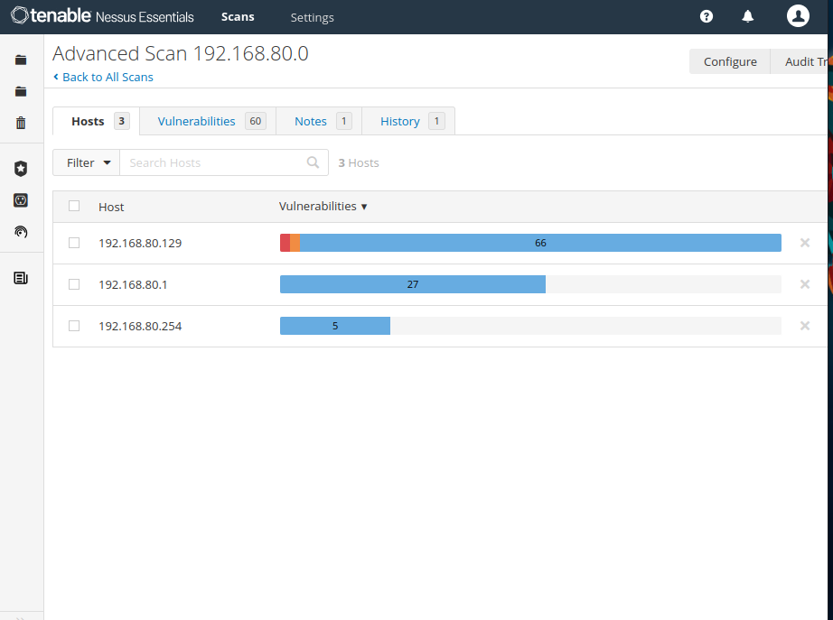

(5), Nmap, Manual Vulnerability Analysis
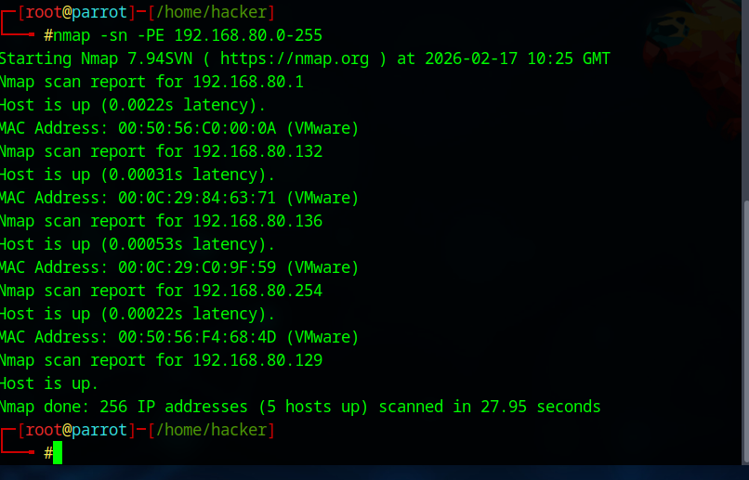

(6) Social Engineering toolkit, Exploitation
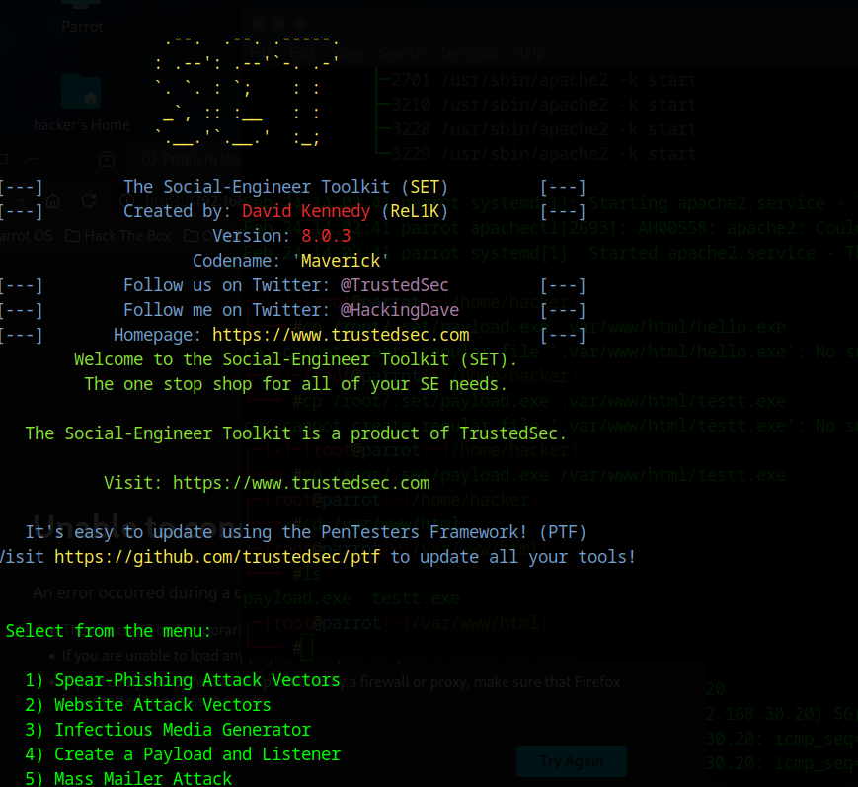

(7) Social Engineering toolkit, Exploitation
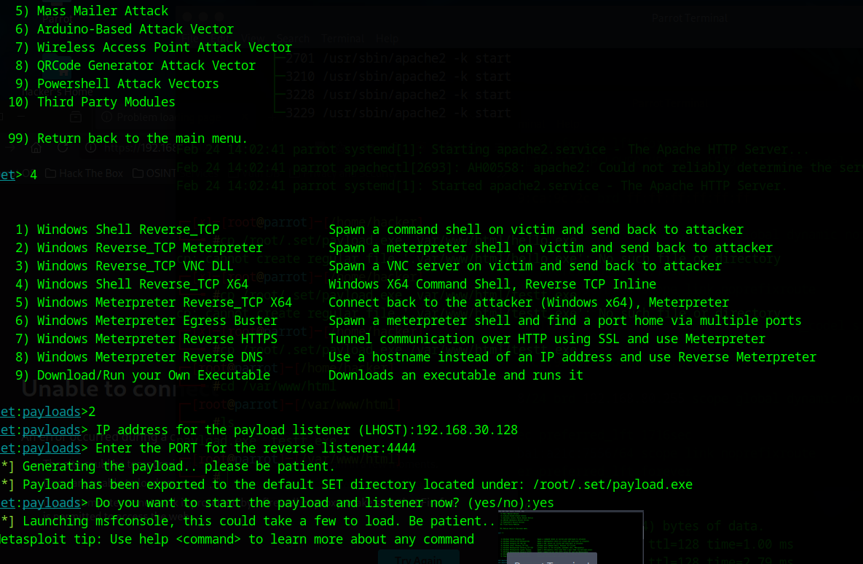

(8) Social Engineering toolkit, Exploitation
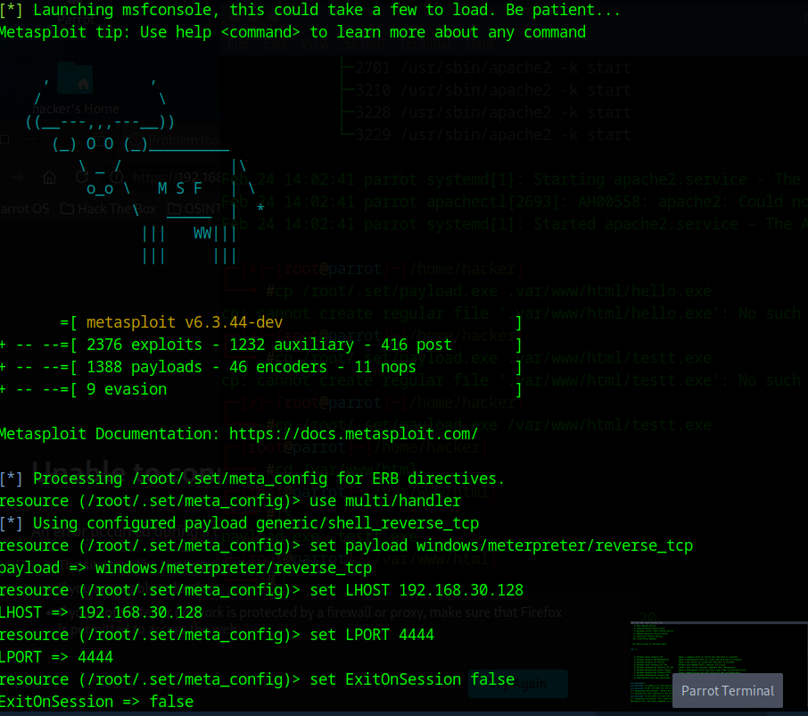

(9) Social Engineering toolkit access gained, Exploitation
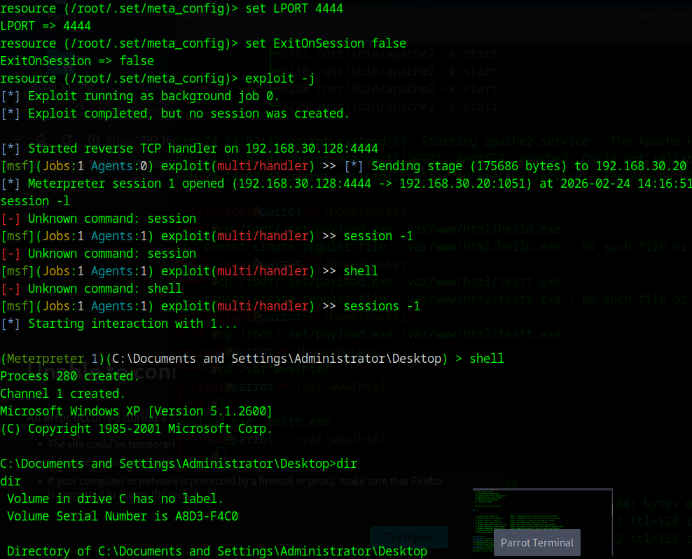

(10) Social Engineering toolkit looking through files, creating files and modfying files, Exploitation
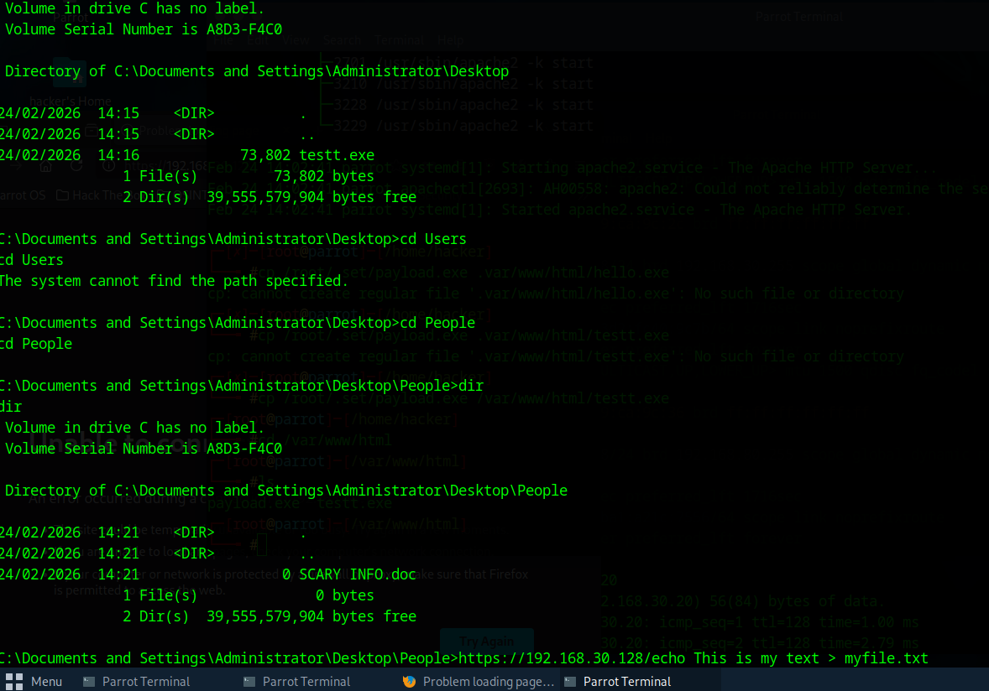
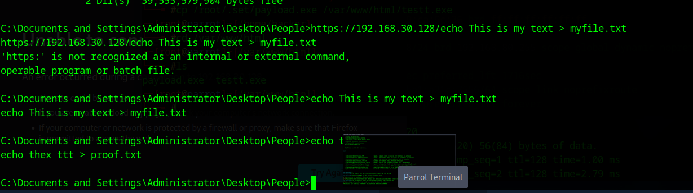

(11) Deleting temport files, clearing event logs a
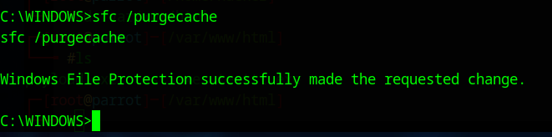
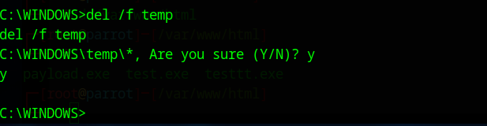
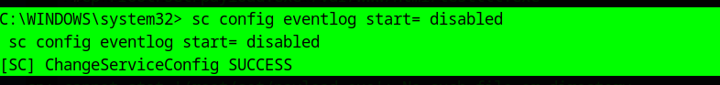
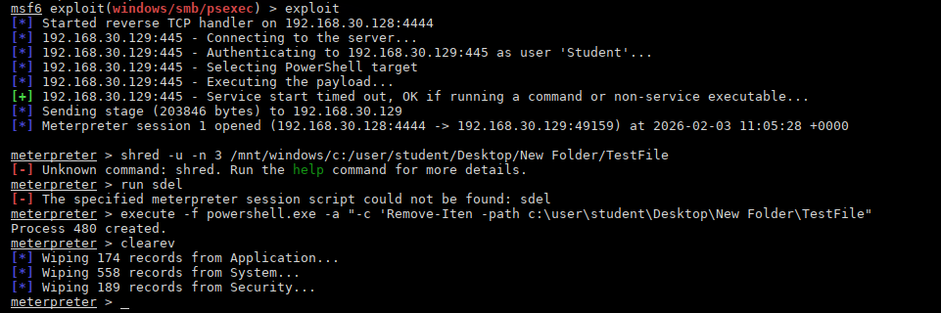
(12), firewall now turned on, Countermeasures
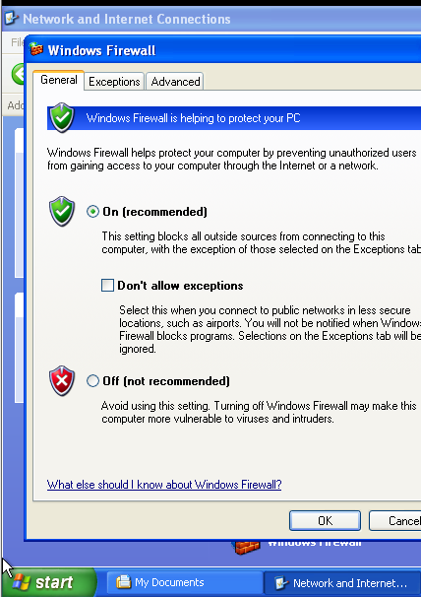

(13), session not created, Countermeasures
